Housing Automation

Ben Seiber

Daniel Wilmot

Jeff Wallace

Jheryl Lezama

Thomas Pionk

## 

## Table of Contents

|  |  |
| --- | --- |
| **Housing Automation (Cover Page)** | Page # |
| **Table of Contents** | 2 - 4 |
| **Section 1.0 – Project Vision** | 5 |
| 1.1 - Project Background | 5 |
| 1.2 - Socio-economical Impact, Business Objectives, and Gap Analysis | 5 - 6 |
| 1.3 - Security and ethical concerns | 6 - 7 |
| 1.4 - Glossary of Key Terms | 7 - 9 |
| **Section 2.0 – Project Planning & Execution** | 9 |
| 2.1 - Team Information | 9 - 10 |
| 2.2 - Tools and Technology | 10 - 11 |
| 2.3 - Project Plan |  |
| 2.4 - Best Standards and Practices |  |
| **Section 3.0 – System Requirements Analysis** |  |
| 3.1 - Functional Requirements |  |
| 3.2 - Non-Functional Requirements |  |
| 3.3 - On-Screen Appearance of landing and other pages requirements |  |
| 3.4 - Wireframe Designs |  |
| **Section 4.0 – System Requirements Specifications and Diagrams** |  |
| 4.1 - Stakeholders |  |
| 4.2 - Actors and Goals |  |
| 4.3 - User Stories, Scenarios and Use Cases |  |
| 4.4 - System Sequence / Activity Diagrams |  |
| **Section 5.0 – User Interface Specifications** |  |
| 5.1 - Preliminary Design |  |
| 5.2 - User Effort Estimation |  |
| **Section 6.0 – Static Design** |  |
| 6.1 - Class Model |  |
| 6.2 - System Operation Contracts |  |
| 6.3 - Mathematical Model |  |
| 6.4 - Entity Relation |  |
| **Section 7.0 – Dynamic Design** |  |
| 7.1 - Sequence Diagrams |  |
| 7.2 - Interface Specification |  |
| 7.3 - State Diagrams |  |
| **Section 8.0 – System Architecture and System Design** |  |
| 8.1 - Subsystems / Component / Design Pattern Identification |  |
| 8.2 - Mapping Subsystems to Hardware (Deployment Diagram) |  |
| 8.3 - Persistent Data Storage |  |
| 8.4 - Network Protocol |  |
| 8.5 - Global Control Flow |  |
| 8.6 - Hardware Requirement |  |
| **Section 9.0 – Algorithms and Data Structures** |  |
| 9.1 - Algorithms |  |
| 9.2 - Data Structures |  |
| **Section 10.0 – User Interface Design and Implementation** |  |
| 10.1 - User Interface Design |  |
| 10.2 - User Interface Implementation |  |
| **Section 11.0 – Testing** |  |
| 11.1 - Unit Test Architecture and Strategy/Framework |  |
| 11.2 - Unit test definition, test data selection |  |
| 11.3 - System Test Specification |  |
| 11.4 - Test Reports per Spring |  |
| **Section 12.0 – Project Management** |  |
| 12.1 - Project Plan |  |
| 12.2 - Risk Assessment |  |
| **Section 13.0 - References** |  |

## 

## Section 1.0 – Project Vision

**1.1 – Project Background**

Home automation or “the internet of things” is not a new concept. However, the benefit of an effective automation and monitoring system is something that cannot be understated. The Home Automation system strives to combine the benefits of housing security, utility monitoring, and cost-saving analytics into one beneficial package. It is our belief that such a system would aid in alerting landlords and tenants to possible issues before a potentially larger incident occurs. This system provides the benefits of receiving live sensor updates regarding water pressure, temperature, humidity, and lighting through the convenience of a website. Additionally, landlords are able to control specific items such a lighting and temperature in hallways and public spaces when the need arises. Furthermore, sensor logs are recorded so that analytics can be later generated in hopes of identifying high-cost utilities. As a result, the home automation system will allow for the automation of a housing facility by using both monitoring and control elements, focusing on building safety and energy savings.

**1.2 – Socio-economical Impact**

**Housing & Health**

The automation of housing utilities not only increases the convenience of the user, but is also a precautionary step taken towards improving the quality of life for both residents and landlords. The automated monitoring of housing elements such as the air quality control of a location can assist in detecting potential hazards and avoid negative impacts on both child and adult health. As a result, these systems can be implemented to increase both awareness and detection therefore leading to an overall improved quality of life.

**Energy & Efficiency Improvements**

Energy waste leads to an increased long-term operating cost for many low-income housing facilities and can be factored into rising housing costs. These costs leave low-income families with a minimal remaining budget for other necessary expenses and limit their chances of accumulating personal savings. The automation and ability to control high-cost factors such a property’s heating can cut the costs on unnecessary or wasteful energy expenses.

**Housing & Security**

Safety and peace of mind are two factors that can drastically reduce stress within the personal lives of many individuals. Through the automation of security cameras and motion detectors, one can lock their doors and monitor activity with the click of a button. This greatly reduces the vulnerability to possible break-ins and other security concerns for both residences and responsible landlords.

**1.2 – Business Objectives**

**Core Values**

* The Home Automation System strives to provide landlords with the tools to reduce long-term utility expenses, increase the level of housing security and identify potential hazards before a possible larger incident occurs.

**Growth**

* The implementation of the Home Automation system could be expanded to reach a wider market in addition to low-income housing. The cost-saving functionality could prove beneficial to manufacturing plants, larger corporations and even public stadiums and arenas in hopes of providing a convenient method of monitoring and cutting long-term energy expenses.

**Productivity**

* Provide landlords with a convenient method of remotely monitoring numerous property utilities.
* Provide landlords with the tools to remotely control their various property utilities.
* Provide landlords with a means of sending alert notifications to the respective property tenants should there be any utility failures or health hazards.
* Provide landlords with generated cost-saving analytics taken from the various sensor readings.
* Provide landlords with the ability to access a log of previously recorded, in addition to live sensor information.

**1.2 – Gap Analysis**

* **Current State (1/24/18):** In terms of productivity, there does not exist any means for a landlord to register properties in order to increase the user convenience as outlined by the project goal. Therefore, we should include a property management system before proceeding further that allows a landlord to actively register properties under their own unique account. This implementation will allow for the landlord to not only keep track of their list of properties, but also visually locate the sensors that are tied to each location.
* **Future State (2/7/18):** The property management system has been implemented and any further refining to this feature will be done as development of the overall Home Automation system continues. An important aspect to keep in mind is that the system is being designed from the perspective of the landlord/building supervisor and any features that assist with monitoring productivity or the system configuration should be heavily considered to meet productivity goals.

**1.3 – Security Concerns & Ethical Concerns**

**Hacking & Stealing Sensitive Information**

* Given that the system design will include the use of a MySQL database, hacking techniques such as MySQL injection and exploiting the default security parameters associated with the MySQL functionality will be addressed. The first precaution will be making the database accessible on a secured private network to limit the number of potential attackers. The second precaution is to research and implement techniques to reduce to the overall risk of SQL data injection or the unauthorized manipulation of using a register function to drop database tables.

**Tenant Privacy**

* While the system shall allow for the controlling of various building utilities such as lighting and temperature, this functionality is strictly limited to public spaces within the property. These spaces will include - but are not limited to - the building’s front doorway, main hallways, front reception area, public laundry rooms, basement, attic and other maintenance or social spaces as to avoid invasion of individual tenant privacy. However, the monitoring of the various property utilities will include the monitoring of individual tenant’s utilities for the purpose of generating more efficient cost-saving analytics based on reducing long-term utility costs.

**Unauthorized Access**

* The system will require landlords to register an account with our database in order to create a verification process that will be used to access the Home Automation System. To improve the security of this verification process, the system will also hash the password entries during both the account registration and login procedure. In addition, the use of the Home Automation System shall be limited to the end-users that register an account and securely login to the system.

**1.4 – Glossary of Terms**

* **Android** - Refers to the operating system found in the end-user mobile application for use with the Home Automation System.
* **Android Studio -** Refers to the software framework that was used to develop the end-user mobile application.
* **Application Program Interface (API) –** Refers to a set of protocols and tools for building software applications and allowing two applications to communicate with one another.
* **Arduino -** Refers to the open-source microcontroller that houses the logic for the various system sensors including lighting, temperature sensor and security.
* **Asynchronous Javascript and XML (AJAX) -** Refers to the scripting language that was used to dynamically generate HTML elements within the end-user web application.
* **Apache Web Server -** Refers to the server that will host the Home Automation System end-user web application.
* **Cascading Style Sheets (CSS) -** Refers to the scripting language that was used to visually style the end-user web application.
* **End-User -** The intended users of the Home Automation system, which are referred to in this document as 1) Landlord, alternatively building supervisor, and 2) Tenant.
* **End-User Application -** Refers to both the web and mobile applications that function as the user interface for the Home Automated System.
* **Gantt Chart -** A visual timeline chart found in Microsoft Project 2016 © that outlines the project timeframe and various deadlines that was used in the team planning and development of the Home Automation System project.
* **Hypertext Markup Language (HTML) -** Refers to the scripting language that was used to develop the end-user web application.
* **Hypertext Preprocessor (PHP) -** Refers to the scripting language that was used to handle the information passed between the end-user web application and the various web servers.
* **Landlord -** Refers to the building manager/supervisor who also functions as an end-user for the Home Automation system.
* **Microsoft Project 2016 © -** The software framework developed by Microsoft © that was used in the team planning and creation of a project schedule for development of the Home Automation System project.
* **MQTT Server -** Refers to the network server that provides communication between the various system sensors (temperature, lighting, etc.), the system database and the end-user software applications.
* **MySQL Server -** Refers the database that will store 1) end-user account information and 2) sensor readings.
* **NodeRed -** Refers to the software framework that supports the communication between the following; MQTT server, MySQL server, Apache Web server, Arduino microcontrollers in addition to the website & mobile applications.
* **Operating System (OS)** - Refers to the software that supports a computer’s or mobile device’s basic functionality including any additional peripheral devices.
* **Property -** Refers to the building or residency that is owned by the landlord.
* **Python -** Refers to the programming language that utilized by the Arduino microcontrollers.
* **Raspberry Pi -** Refers to the miniature computer device that will function to host the MQTT server, MySQL server, NodeRed server and the Apache Web server.
* **Sensor/Asset -** Refers to the individual system sensors including - but not limited to - temperature, water pressure, motion detectors, etc. and property lighting.
* **Tenant -** Refers to the residents that reside at a building/property.
* **User Interface (U.I.) -** The interface that the end-user will interact with in order to use the Home Automation System and encompasses both the visual style and layout of the application.
* **Wamp Server -** The software used to host the web application for both development and testing purposes.

Section 2.0 – Project Execution & Planning

**2.1 – Team Information**

* **Ben Seiber**
  + Project Lead & Designer of the Home Automation system physical model including the CNC laser cutting of the model itself, the electrical wiring of the model, the coding of the Arduino logic and designer of the physical hardware layout.
* **Daniel Wilmot** 
  + Lead programmer of the web application including the HTML, CSS, PHP and AJAX code and co-designer of the web application user interface design. In addition, responsible for implementing the database using PHP MyAdmin and also troubleshooting & testing website code.
* **Jeff Wallace**
  + Lead designer of the Home Automation System user interface and in addition to designing the various system schemas including database design, application page layout & orientation and wireframe schematics. Also responsible for assisting with the coding of the web application.
* **Jheryl Lezama**
  + Project Planner and also responsible for documenting the development of the Home Automation System. Created the use cases, user stories, functional and nonfunctional requirements in addition to the Activity & Sequence Diagrams for each. Also responsible for assisting with the coding of the web application.
* **Thomas Pionk**
  + Lead designer of the back-end system network including the server configurations and various PowerShell scripts that allowed for communication between the various hardware elements. Also designed the system U.I. dashboard used for controlling the various system sensors and configuring the NodeRed networking schema.

**2.2 – Tools and Technology**

The tools and technology for this project was broken down into two categories consisting of both hardware and software. Therefore, each of these frameworks has been represented within the respective table below.

|  |  |  |
| --- | --- | --- |
| **Hardware** | | |
| **Type of Hardware** | **Purpose of Hardware** | **Device** |
| Individual | Development | Dell Latitude © |
| Individual | Development | Apple Macbook Pro © |
| Individual | Development & Testing | Android OS Mobile Phone |
| On-Premise | Deployment & Testing | Arduino © |
| On-Premise | Development | CNC Laser Cutter |
| On-Premise | Deployment & Testing | Raspberry Pi |
| On-Premise | Deployment & Testing | Air Purity Sensor |
| On-Premise | Deployment & Testing | LED Lighting |
| On-Premise | Deployment & Testing | Humidity Sensor |
| On-Premise | Deployment & Testing | Motion Sensor |
| On-Premise | Deployment & Testing | Temperature Sensor |

|  |  |  |
| --- | --- | --- |
| **Software** | | |
| **Type of Framework** | **Purpose of Framework** | **Software Program** |
| Individual | Team Collaboration | GroupMe © |
| Individual | Development | Android Studio © |
| Individual | Development | Arduino C-Scripting |
| Individual | Development | Sublime Text Editor © |
| Individual | Development | Python © |
| Individual | Development | Text Editor |
| Individual | Development | Command Line, PowerShell © |
| Individual | Project Management | Microsoft Project 2016 © |
| On-Premise | Development | MySQL Server © |
| On-Premise | Development | MySQL Workbench © |
| On-Premise | Development | PHPmyAdmin © |
| On-Premise | Development | MQTT Server |
| On-Premise | Development & Testing | Fusion 360 © |
| Cloud-Based | Team Collaboration | Github © |
| Cloud-Based | Team Collaboration | Google Drive © |
| Cloud-Based | Team Collaboration | Google Hangouts © |
| Open API | Development | NodeRed © |
| Open API | Development | Wamp Server © |

**2.3 – Project Plan (Needs Updating)**

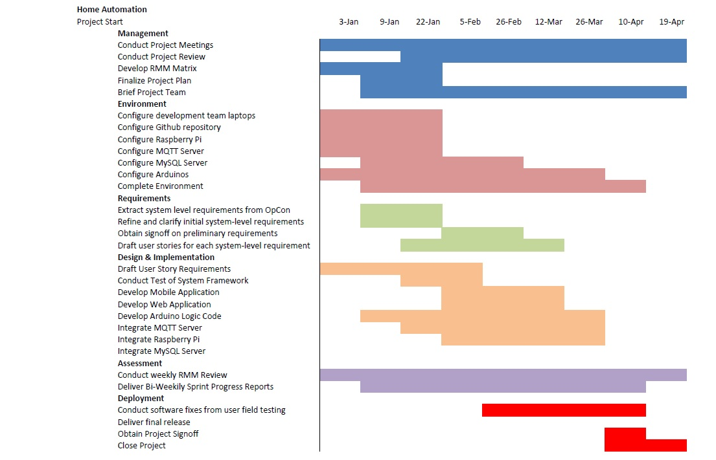

**2.4 – Best Standards and Practices**

**Better Targeting**

* Alerts and notifications are less likely to be intercepted by an unintended party if the system is hosted on a private network.

**Lower Costs**

* Generating cost-saving analytics that can be used to reduce long-term utility expenses and energy expense.

**Reliability**

* The website application for managing the system will be made available 99.98% of the time.
* The end-user account information will be stored within the database with no data loss.

**System Security**

* The website will hash the password entry during both the registration and login process to increase system security.
* The MySQL database will store passwords as hashes in addition to protecting itself from potential SQL injections.
* The MQTT server will only be accessible on the private network.

## Section 3.0 – System Requirements Analysis

**3.1 – Functional Requirements**

|  |  |
| --- | --- |
| General Requirement ID: 01 | Priority: Low |
| Requirement: Account Registration | |
| Actor(s): Landlord | Assigned to: Danny Wilmot, Jheryl Lezama, Jeff Wallace |
| Description:   1. The system shall provide landlords the ability to register a unique account using either the website or mobile application. 2. The system will require the following information when registering an account:  1) Email 2) Password 3. Further Notes: 1) The system will hash the password entry in order to increase system security.  2) The system will save a landlord’s account information within the database with no data loss.  3) The landlord’s account will unique from other accounts stored within the MySQL database. | |

|  |  |
| --- | --- |
| General Requirement ID: 02 | Priority: Low |
| Requirement: Account Login | |
| Actor(s): Landlord | Assigned to: Danny Wilmot, Jheryl Lezama, Jeff Wallace |
| Description:   1. The system shall provide landlords the ability to login to their own unique account via the website or mobile application. 2. The system will require the following information when logging into an account:  1) Email 2) Password 3. Further Notes: 1) The system will hash the password entry in order to increase system security.  2) The system will save a landlord’s account information within the database with no data loss.  3) The system will only access relevant account information that is associated with that particular account. | |

|  |  |
| --- | --- |
| General Requirement ID: 03 | Priority: High |
| Requirement: Remotely Monitoring the Sensors/Assets | |
| Actor(s): Landlord | Assigned to: Ben Seiber, Thomas Pionk |
| Description:   1. The system shall provide landlords the ability to remotely monitor the information being recorded by sensors/assets including lighting, temperature, humidity, etc. via the website or mobile application. 2. Further Notes: 1) The ability to remotely monitor the various system sensors shall only be granted to users who have both registered and securely logged into the system via the website or mobile application.  2) The monitor feature will not be limited only to public spaces and will extend to individual tenant’s spaces for the purpose of generating more accurate cost-saving analytics.  3) The monitoring of the sensor/asset information will be unique to each registered property associated with that particular landlord’s account. | |

|  |  |
| --- | --- |
| General Requirement ID: 04 | Priority: High |
| Requirement: Remotely Controlling the Sensors/Assets | |
| Actor(s): Landlord | Assigned to: Ben Seiber, Thomas Pionk |
| Description:   1. The system shall provide landlords the ability to remotely control the various sensors/assets including lighting, temperature, humidity, etc. via the website or mobile application. 2. Further Notes: 1) The ability to remotely monitor the various system sensors shall only be granted to users who have both registered and securely logged into the system via the website or mobile application.  2) The control feature will be limited only to public spaces and will not extend to individual tenant’s spaces as to avoid breach of privacy.  3) The controlling of the sensor/asset information will be unique to each registered property associated with that particular landlord’s account. | |

|  |  |
| --- | --- |
| General Requirement ID: 05 | Priority: High |
| Requirement: Accessing Sensor/Asset Logging Information | |
| Actor(s): Landlord | Assigned to: Ben Seiber, Daniel Wilmot, Jheryl Lezama, Jeff Wallace, Thomas Pionk |
| Description:   1. The system shall provide landlords the ability to view the logging of sensor/asset information including lighting, temperature, humidity, etc. via the website or mobile application. 2. Further Notes: 1) The system will use a MySQL database to store the sensor/asset readings.  2) The sensor/asset information will be unique to each registered property associated with that particular landlord’s account.  3) The website or mobile application will provide the means to interface with the MySQL database in order to view the stored sensor readings. | |

|  |  |
| --- | --- |
| General Requirement ID: 06 | Priority: High |
| Requirement: Generating Cost-Saving Analytics | |
| Actor(s): Landlord | Assigned to: Ben Seiber, Daniel Wilmot, Jheryl Lezama, Jeff Wallace, Thomas Pionk |
| Description:   1. The system shall provide landlords with cost-saving analytics based on the logged sensor/asset information that could then be used to reduce long-term utility expense. 2. Further Notes: 1) The system will use a MySQL database to store the sensor/asset readings.  2) The cost-saving analytics will be unique to each registered property associated with that particular landlord’s account.  3) The website or mobile application will provide the means to interface with the MySQL database in order to generate the cost-saving analytics. | |

|  |  |
| --- | --- |
| General Requirement ID: 07 | Priority: Medium |
| Requirement: Registering Properties | |
| Actor(s): Landlord | Assigned to: Daniel Wilmot, Jheryl Lezama, Jeff Wallace |
| Description:   1. The system shall provide landlords with the ability to register a list of multiple properties under their own account. This will provide landlords with a means to keep track of their various properties in addition to the sensors that occupy each one. 2. Further Notes: 1) The property information will be stored in a MySQL database.  2) Each newly registered property will be unique from each other (no duplicates).  3) Each registered property will be unique to the account to which it was registered to and will not be accessible by another account. | |

**3.2 - Non-Functional Requirements**

**MySQL Database**

* The MySQL database will store landlord account information with no data loss.
* The MySQL database will be able to store at least 100 sensor/asset information snapshots within a log file.
* The MySQL database will be implemented with an industry standard relational database schema.

**Server Availability**

* The MQTT Server shall provide the back-end network functionality and be available 99.98% of the time.
* The MQTT will be hosted on a private network only accessible to those who have securely registered and logged into the Home Automation system.

**Website Requirement**

* The website shall be accessible on both Windows and Mac OS devices.
* The website shall be able to load on both computer and mobile phone devices.
* The website application pages shall be compatible with HTML 4.0 or higher.
* As a minimum, the website application pages shall be compatible Firefox, Chrome, Safari and Internet Explorer.

**3.3 – On-Screen Appearance of landing and other pages requirements  
  
1) Login – Includes an account registration form as outlined in use case (UC-#01) and a forgot password recovery option.**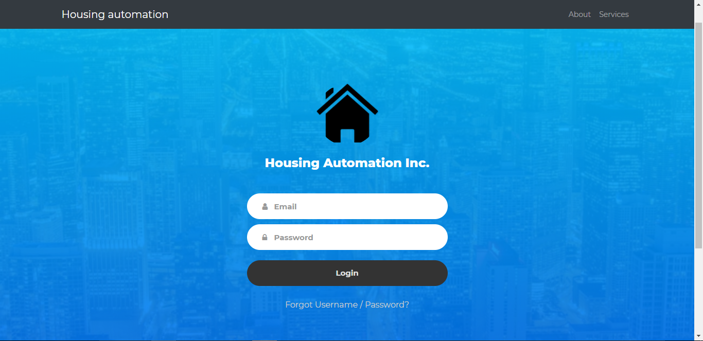

**2) Dashboard – Includes a property registration form as outlined in use case (UC-#03), includes the ability to upload photos for each property using a generated c-drive folder tied to each landlord account. Note: The properties being displayed are tied to each unique account.**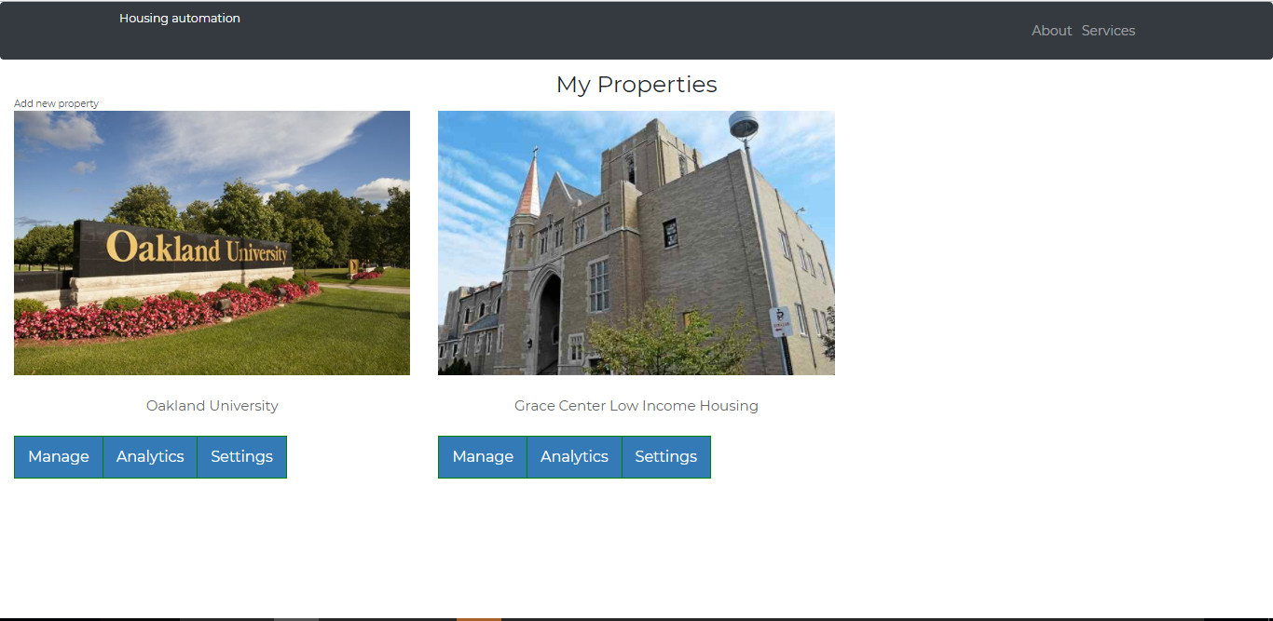

**3.4 – Wireframe Designs**

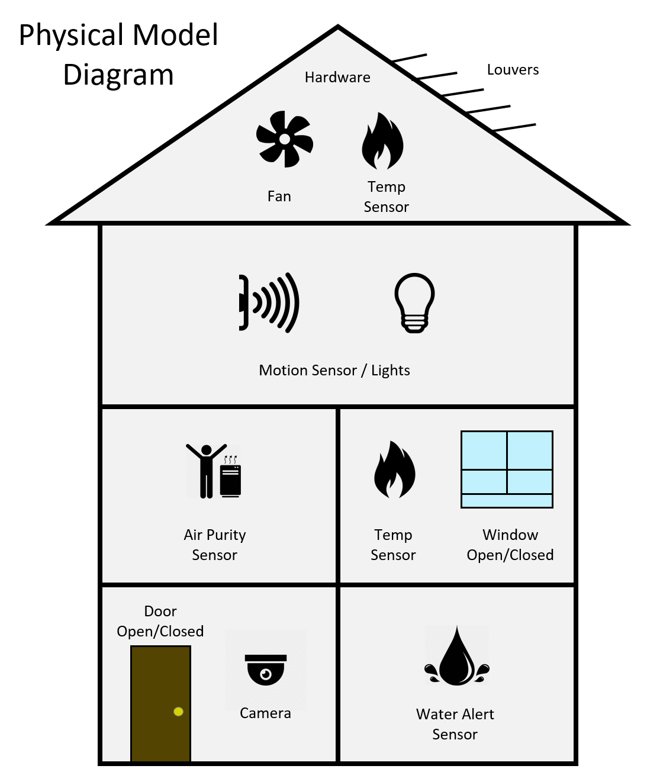

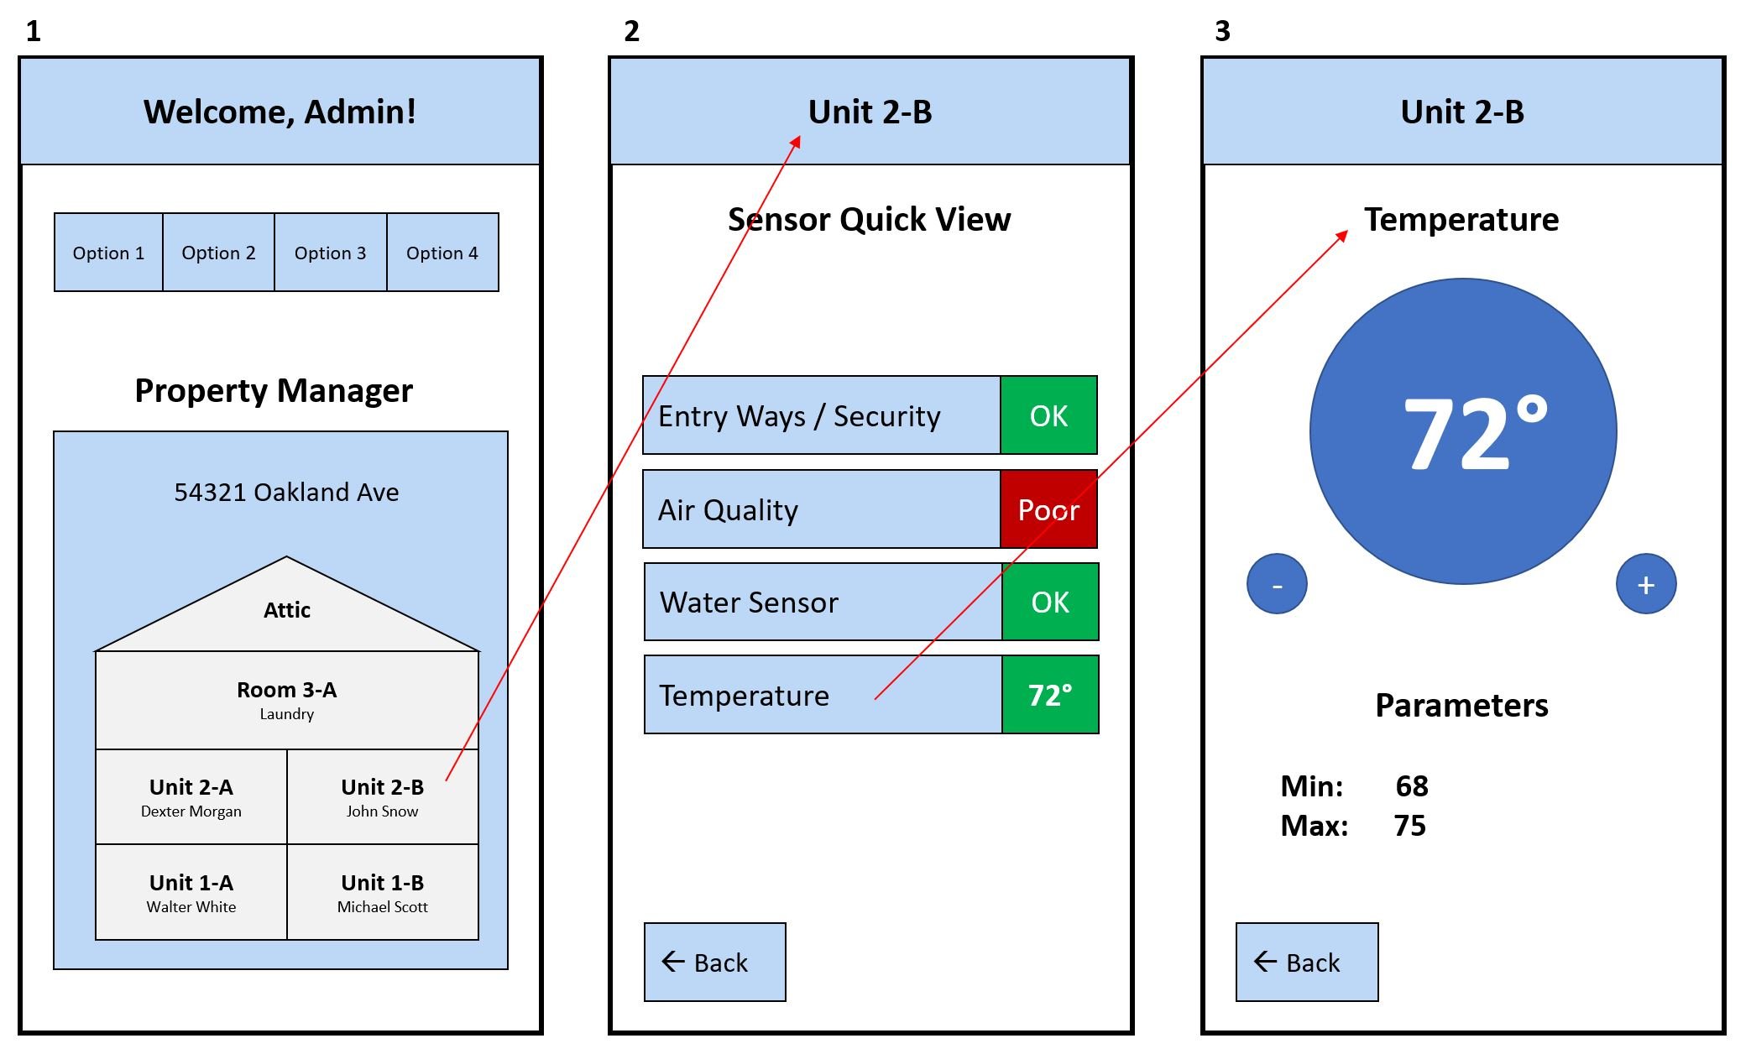

Section 4.0 – Functional Requirements Specification

**4.1 – Stakeholders**

**Customers**

* Dr. Nilesh Patel
* Grace Centers of Hope
* Landlord and building supervisors managing a housing facility

**Project Manager**

* Ben Seiber

**Project Team Members**

* Ben Seiber
* Daniel Wilmot
* Jeff Wallace
* Jheryl Lezama
* Thomas Pionk

**Project Sponsor**

* Grace Centers of Hope

**Steering Committee**

* Dr. Nilesh Patel

**Executives**

* Dr. Nilesh Patel

**Resource Managers**

* Oakland University

**4.2 – Actors and Goals**

|  |  |
| --- | --- |
| **Actor(s)** | **Goal(s)** |
| **Landlord** | 1. Register an account for use with the system 2. Register properties for use with the system 3. Ability to remotely control sensors 4. Ability to remotely monitor sensors |
| **MQTT Server** | 1. Allow for communication between the website application and MySQL database 2. Allow for communication between the website application and various housing sensors 3. Allow for logging of sensor data |
| **MySQL** | 1. Stores landlord account information 2. Stores sensor readings/data |
| **NodeRed** | 1. Allows for easier integration between hardware and software 2. Allows for easier configuration of the back-end network support |

**4.3 – User Stories**

|  |  |  |
| --- | --- | --- |
| **Identifier** | **User Story** | **Size** |
| ST-1 | As a landlord, I want a secure registration process that safely stores my personal information within a database. | 3pts |
| ST-2 | As a landlord, I want a secure login process that grants me access to my own unique account separate from others. | 3pts |
| ST-3 | As a landlord, I want a way to view sensor/asset information as gathered from my various properties. | 9pts |
| ST-4 | As a landlord, I want a way to control the various utilities within the public spaces of each of my property. | 9pts |
| ST-5 | As a landlord, I want to see generated cost-saving analytics that could help me save money in regards to long-term utility expenses. | 6pts |

**4.3 – Scenarios**

**User Scenario – Becoming a new user**

Upon deciding that a customer (being a housing landlord) would like to use our service, they would log on to our website (www.HomeAutomation.com) and register as a new user. The website will prompt them for a username and password, their first and last name, as well as their email address. After such information has been entered, the customer will click the register button, and given there is no conflict with the information (i.e. the username already exists, or the password format is unacceptable), the user will be registered.

**User Scenario – Logging in and viewing sensor data/statuses of a property**

Upon wanting to login to their user account and view the status of their housing complex, the landlord would visit our HomeAutomation website and click the login button (given they have already completed the user/property registration process). The landlord will be prompted for their username and password; upon entering the correct information, they will be logged in.

Once logged in, the landlord will click on the manage button associated with the property of their choosing. On the manage page, the customer will be shown the data related to that property. More to come on this paragraph.

**User Scenario – Generate cost-saving analytics**

Upon wanting to view HomeAutomation analytics related to an owned property, the landlord would login to their user account, click on the property they wish to view metrics on, and then click on the “View Analytics” button.

**4.3 – Use Cases**

|  |  |  |
| --- | --- | --- |
| **UC-#01** | | **Account Registration** |
| Related Requirements: | | None |
| Initiating Actor: | | Landlord |
| Actor’s Goal: | | Register an account within the database for use with the Home Automation system. |
| Participating Actors: | | MySQL Database, Website Application, Mobile Application. |
| Trigger Action: | | User requests to register an account. |
| Pre-Conditions: | | System does not already contain any prior account information regarding the landlord. |
| Post-Conditions: | | System stores the landlord account information within the MySQL database. |
| **Flow of Events for Main Success Scenario:** | | |
| 🡪 | 1. | Landlord selects register new account on the login page. |
| 🡨 | 2. | The system responds by displaying an account registration form for the landlord to enter personal account information. |
| 🡪 | 3. | The landlord enters personal account information into the account registration form. |
| 🡪 | 4. | The landlord presses the submit button once they have completed filling out the account registration form. |
| 🡨 | 5. | The system responds by first checking that all of the entry fields have information entered. |
| 🡨 | 6. | The system responds by checking the provided information against the information stored within the database to insure that there exists no duplicate account information. |
| 🡨 | 7. | **(Exit Condition)** The system responds with visual message confirmation that an account has been successfully registered within the database. |
| **Flow of Events for Main Success Scenario (Alternate Scenario):** | | |
| 🡨 | 5a. | The system responds with a visual error message that all of the entry fields have not been completed. |
| 🡨 |  | The system does not create an account until all of the form fields contain the necessary information. |
| 🡨 |  | Same as in Step 3 above. |
| 🡨 | 6a. | The system responds with a visual error message that the information entered within the account registration form already exists within the database. |
| 🡨 |  | The system does not create a new account given the existence of duplicate account information within the database. |
| 🡪 |  | Same as in Step 3 above. |
| 🡨 | 6a. | The system responds with a visual error message that there was an error connecting to the database. |
| 🡨 |  | The system does not create a new account within the database. |

|  |  |  |
| --- | --- | --- |
| **UC-#02** | | **Account Login** |
| Related Requirements: | | UC-#01 |
| Initiating Actor: | | Landlord |
| Actor’s Goal: | | Gain access to an account that was previously registered to the database in order to begin using the features of system. |
| Participating Actors: | | MySQL Database, Website Application, Mobile Application. |
| Trigger Action: | | User requests to access their previously registered account in order to gain access to the features of the system. |
| Pre-Conditions: | | System already contains previously registered account information. |
| Post-Conditions: | | Landlord logs into their unique account. |
| **Flow of Events for Main Success Scenario:** | | |
| 🡪 | **1.** | Landlord enters account information on the login page. |
| 🡪 | 2. | Landlord presses the login/submit button after entering the required information. |
| 🡨 | 3. | The system responds by checking the provided login account information against the information stored within the database. |
| 🡨 | 4. | The system logs the landlord into their unique account. |
| 🡨 | 5. | **(Exit Condition)** The system further responds with visual confirmation message that the landlord has successfully logged into their account. |
| **Flow of Events for Main Success Scenario (Alternate Scenario):** | | |
| 🡨 | 3a. | The system responds with a visual error message that the login account information provided was incorrect. |
| 🡪 |  | Same as in Step 1 above |

|  |  |  |
| --- | --- | --- |
| **UC-#03** | | **Register Property** |
| Related Requirements: | | UC-#01, UC-#02 |
| Initiating Actor: | | Landlord |
| Actor’s Goal: | | To register a new property within the database. |
| Participating Actors: | | MySQL Database, Website Application, Mobile Application. |
| Trigger Action: | | The landlord has selected the option to “add new property”. |
| Pre-Conditions: | | The landlord has successfully logged into their unique account and has requested to “add a property”. |
| Post-Conditions: | | The property information has been successfully registered within the database and is now displayed on the property management dashboard. |
| **Flow of Events for Main Success Scenario:** | | |
| 🡪 | 1. | Landlord selects “add a property” feature from the property management dashboard. |
| 🡨 | 2. | The system responds by receiving the request and displays a form for the landlord to enter in property information. |
| 🡪 | 3. | The landlord enters the property information into the form fields. |
| 🡪 | 4. | The landlord presses the “add” button after entering the property information into each of the form fields. |
| 🡨 | 5. | The system responds by first checking that all of the entry fields have information entered. |
| 🡨 | 6. | The system then opens a PHP request to store the property information within the database. |
| 🡨 | 7. | The system then returns the landlord back to the property management dashboard. |
| 🡨 | 8. | **(Exit Condition)** The system then displays the newly registered property information on the property management dashboard. |
| **Flow of Events for Main Success Scenario (Alternate Scenario):** | | |
| 🡨 | 5a. | The system responds with an error message that “all of the required form fields have not been completed”. |
| 🡪 |  | (Same as in step 3) |
| 🡨 | 8a. | The system displays an error message stating that, “no properties have been registered due to a PHP connection error”. |
| 🡪 |  | (Same as in step 1) |

|  |  |  |
| --- | --- | --- |
| **UC-#04** | | **Edit Property** |
| Related Requirements: | | UC-#01, UC-#02, UC-#03 |
| Initiating Actor: | | Landlord |
| Actor’s Goal: | | To edit listed property information stored within the database |
| Participating Actors: | | MySQL Database, Website Application, Mobile Application. |
| Trigger Action: | | Landlord desires to update/change a registered property’s information. |
| Pre-Conditions: | | The landlord already has a registered property and has selected the option to edit property information. |
| Post-Conditions: | | The property information has been successfully updated within the database. |
| **Flow of Events for Main Success Scenario:** | | |
| 🡪 | 1. | The landlord selects the “settings” option on the property task bar for the property they wish to edit. |
| 🡨 | 2. | The system responds by receiving the request and opening the property management page for that specific property. |
| 🡪 | 3. | The landlord selects the “edit” option on the property management page. |
| 🡨 | 4. | The system responds by displaying an edit property information form. |
| 🡪 | 5. | The landlord makes the necessary changes to the respective form fields regarding the information they wish to change. |
| 🡪 | 6. | The landlord presses the “submit” button to confirm the changes they have made to the property information. |
| 🡨 | 7. | The system responds by first checking that all of the entry fields are complete. |
| 🡨 | 8. | The system uses PHP to connect to the database and performs a update to the stored property information. |
| 🡨 | 9. | The system then returns the landlord back to the main page. |
| 🡨 | 10. | **(Exit Condition)** The system then displays the newly edited property information on the main page. |
| **Flow of Events for Main Success Scenario (Alternate Scenario):** | | |
| 🡨 | 7a. | The system responds with an error message that “all of the required form fields have not been completed”. |
| 🡪 |  | (Same as in step 5) |

|  |  |  |
| --- | --- | --- |
| **UC-#05** | | **Delete Property** |
| Related Requirements: | | UC-#01, UC-#02, UC-#03 |
| Initiating Actor: | | Landlord |
| Actor’s Goal: | | To delete property information stored within the database. |
| Participating Actors: | | Web Application, Mobile Application, MySQL Database. |
| Trigger Action: | | The landlord wishes to delete a property listed on their property management dashboard. |
| Pre-Conditions: | | The landlord already has a registered property and has selected the option to delete property information |
| Post-Conditions: | | The property information has been successfully deleted from the database and is no longer displayed on the property management dashboard. |
| **Flow of Events for Main Success Scenario:** | | |
| 🡪 | 1. | The landlord selects the “manage” option on the property task bar for the property they wish to edit. |
| 🡨 | 2. | The system responds by receiving the request and opening the property management page for that specific property. |
| 🡪 | 3. | The landlord selects the “delete” option on the property management page. |
| 🡨 | 4. | The system receives the request and responds with a dialogue box asking if they wish to confirm the deletion of the property. |
| 🡪 | 5. | The landlord confirms the action to delete the property information using the dialogue box. |
| 🡪 | 6. | The system opens a PHP connection to the database to delete the associated property information. |
| 🡨 | 7. | The system then returns the landlord back to the property management dashboard. |
| 🡨 | 8. | **(Exit Condition)** The system then removes the property information from the property management dashboard. |
| **Flow of Events for Main Success Scenario (Alternate Scenario):** | | |
| 🡪 | 5a. | The landlord does not confirm the property deletion from the dialogue box and cancels the decision to delete the property information. |
| 🡨 |  | The system then returns the landlord back to the property management dashboard. |
| 🡨 |  | **(Exit Condition)** The property information is still displayed on the property management dashboard and has not been deleted. |

|  |  |  |  |
| --- | --- | --- | --- |
| **UC-#06** | | | **Remote Monitoring** |
| Related Requirements: | | | UC-#01, UC-#02, UC-#03 |
| Initiating Actor: | | | Landlord |
| Actor’s Goal: | | | To remotely monitor the sensor/asset information within a particular property via the web or mobile application. |
| Participating Actors: | | | Sensor/Asset, MQTT Server, Web Application, Mobile Application. |
| Trigger Action: | | | Landlord requests to view the sensor/asset log information of a particular property. |
| Pre-Conditions: | | | Landlord has selected view sensor/asset information from property management screen. |
| Post-Conditions: | | | Landlord is taken to a dashboard that displays the sensor/asset information for that specified property. |
| **Flow of Events for Main Success Scenario:** | | | |
| 🡪 | | 1. | Landlord selects a registered property. |
| 🡨 | | 2. | The system responds by visually displaying the desired property information. |
| 🡪 | | 3. | The landlord selects the option to view sensor/asset information for that property. |
| 🡨 | | 4. | The system receives the request to view sensor/asset information and forwards the request to the MQTT Server. |
| 🡨 | | 5. | The MQTT server receives the request and sends the requested information to the application. |
| 🡨 | | 6. | The application receives the sensor/asset information data from the MQTT server. |
| 🡨 | | 7. | **(Exit Condition)** The system visually displays the sensor/asset information dashboard for the specified property to the landlord. |
| **Flow of Events for Main Success Scenario (Alternate Scenario):** | | | |
| 🡨 | 2a. | | The system responds with a visual error message that the property information cannot be retrieved from the database. |
| 🡪 |  | | (Same as in step 1) |
| 🡨 | 4a. | | The system responds with a visual error message that the property sensor/asset information cannot be retrieved. |
| 🡪 |  | | (Same as in step 3) |

|  |  |  |
| --- | --- | --- |
| **UC-#07** | | **Remote Control** |
| Related Requirements: | | UC-#01, UC-#02, UC-#03 |
| Initiating Actor: | | Landlord |
| Actor’s Goal: | | To remotely control a property sensor/asset via the web or mobile application (ex: turn off the lights) |
| Participating Actors: | | Sensor/Asset, MQTT Server, Web Application, Mobile Application |
| Trigger Action: | | The landlord wishes to make an adjustment to a utility asset based on sensor readings. |
| Pre-Conditions: | | Landlord has selected control sensor/asset from property management screen. |
| Post-Conditions: | | Landlord has visually changed the status of a sensor/asset setting. |
| **Flow of Events for Main Success Scenario:** | | |
| 🡪 | 1. | Landlord selects a registered property. |
| 🡨 | 2. | The system responds by visually displaying the desired property information. |
| 🡪 | 3. | The landlord selects the option to control a utility for that property. |
| 🡨 | 4. | System responds by sending the request to the MQTT server. |
| 🡨 | 5. | System further responds by visually displaying a system control dashboard to the landlord. |
| 🡪 | 6. | Landlord inputs the necessary changes to the sensor/asset dashboard. |
| 🡪 | 7. | Landlord submits the change to the sensor/asset information. |
| 🡨 | 8. | The MQTT Server receives the request and processes the change in sensor/asset setting. |
| 🡨 | 9. | System visually displays the change on the sensor/asset dashboard. |
| **Flow of Events for Main Success Scenario (Alternate Scenario):** | | |
| 🡨 | 2a. | The system responds with a visual error message that the property information cannot be retrieved from the database. |
| 🡪 |  | (Same as in step 1) |
| 🡨 | 4a. | The system responds with a visual error message that the request could not be sent to the MQTT Server. |
| 🡪 |  | (Same as in step 3) |

|  |  |  |
| --- | --- | --- |
| **UC-#08** | | **Generating Cost-Saving Analytics** |
| Related Requirements: | |  |
| Initiating Actor: | |  |
| Actor’s Goal: | |  |
| Participating Actors: | |  |
| Trigger Action: | |  |
| Pre-Conditions: | |  |
| Post-Conditions: | |  |
| **Flow of Events for Main Success Scenario:** | | |
|  |  |  |

**4.4 – System Sequence / Activity Diagrams**

1. Please see the “HomeAutomation.asta” for the Activity and Sequence Diagrams corresponding to each use case.

Section 5.0 – User Interface Specifications

**5.1 – Preliminary Design**

**5.2 – User Effort Estimation**

Section 6.0 – Static Design

**6.1 – Class Model**

**6.2 – System Operations Contract**

**6.3 – Mathematical Model**

**6.4 – Entity Relation**

Section 7.0 – Dynamic Design

**7.1 – Sequence Diagram**

1. Please see the “HomeAutomation.asta” for the Activity and Sequence Diagrams corresponding to each use case.

**7.2 – Interface Specification**

**7.3 – State Diagrams**

Section 8.0 – System Architecture and System Design

**8.1 – Subsystems / Component / Design Pattern Identification**

**8.2 – Mapping Subsystems to Hardware (Deployment Diagram)   
8.3 – Persistent Data Storage   
8.4 – Network Protocol   
8.5 – Global Control Flow   
8.6 – Hardware Requirement**

Section 9.0 – Algorithms and Data Structures

**9.1 – Algorithms   
9.2 – Data Structures**

Section 10.0 – User Interface Design and Implementation

**10.1 – User Interface Design   
10.2 – User Interface Implementation**

Section 11.0 – Testing

**11.2 – Unit test definition, test data selection**

**11.3 – System Test Specification**

**11.4 – Test Reports per Sprint**

Section 12.0 – Project management

**12.1 – Project Plan  
12.2 – Risk management**

* Please see “HomeAutomationRMM.xlsx” for details regarding the risk management matrix.

Section 13.0 – References

<http://homeforallsmc.com/wp-content/uploads/2017/05/Impact-of-Affordable-Housing-on-Families-and-Communities.pdf>

<https://freshome.com/2013/01/17/top-10-benefits-of-automating-your-home/>

<http://smallbusiness.chron.com/10-important-business-objectives-23686.html>

<https://www.guru99.com/mis-ethical-social-issue.html>

<http://www.infoentrepreneurs.org/en/guides/best-practice/>

<http://www.fao.org/docrep/U3160E/u3160e09.htm>

<http://intellspot.com/functional-requirements-examples/>

<https://www.wrike.com/project-management-guide/faq/what-is-a-stakeholder-in-project-management/>

<http://projectmanager.com.au/program-management-actors/>